**Project 1: AnomaData (Automated Anomaly Detection for Predictive Maintenance)**

The AnomaData project aims to develop an automated anomaly detection system for predictive maintenance across various industries. Predictive maintenance is crucial in minimizing operational risks and costs associated with equipment failures. By leveraging data-driven insights, organizations can perform maintenance proactively, preventing unexpected breakdowns and optimizing resource allocation.

This capstone project utilizes a dataset consisting of over 18,000 rows, where the target variable (denoted as ‘y’) indicates the presence of anomalies (1 for anomaly, 0 for normal operation). The primary goal is to predict machine breakdowns by identifying anomalies in the dataset.

The project follows a systematic approach that includes:

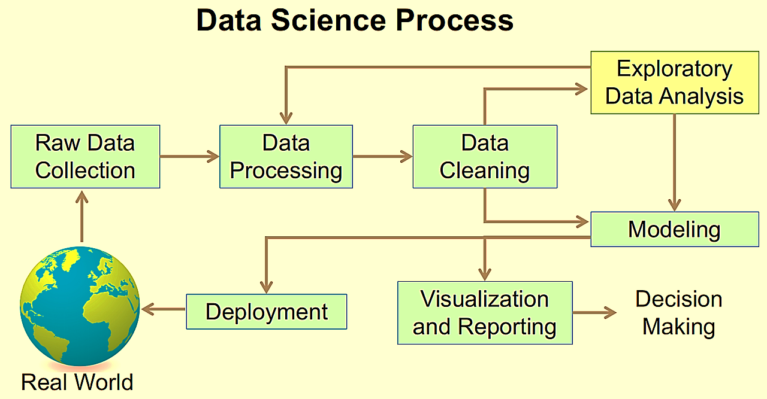

**Exploratory Data Analysis (EDA):** A thorough examination of the dataset is conducted to uncover patterns, relationships, and trends. Descriptive statistics and visualizations are employed to assess the data's quality and distribution.

**Data Preprocessing:** The dataset undergoes rigorous cleaning, addressing missing values, handling outliers, and ensuring consistent data formats.

**Feature Engineering:** New features are created, and existing ones are transformed to enhance model performance, focusing on capturing essential information relevant to the prediction task.

**Model Selection:** Various machine learning algorithms are evaluated to identify the most suitable model for the problem. The trade-offs between model interpretability and predictive power are considered.

**Model Training and Evaluation:** The dataset is split into training and test sets, with the model trained on the training data. The model's performance is evaluated using relevant metrics, ensuring it generalizes well to unseen data.

**Model Deployment:** Plans for deploying the trained model are outlined, detailing how it can be integrated into real-world systems to facilitate real-time predictions.

Throughout the project, documentation is prioritized, ensuring that each step is clearly articulated. Visualizations are used effectively to communicate insights and model results, enhancing understanding for both technical and non-technical stakeholders.

**Conclusion**

The AnomaData project successfully demonstrates the application of machine learning techniques in predictive maintenance through automated anomaly detection. By systematically exploring the dataset, preprocessing it, and developing a robust predictive model, the project highlights the importance of data-driven decision-making in maintaining operational efficiency.

The model achieves an accuracy of over 75% on the test dataset, validating its effectiveness in identifying anomalies. This capability not only reduces the risks associated with equipment failures but also promotes proactive maintenance strategies that can lead to significant cost savings for organizations.

Future work can focus on refining the model further through hyperparameter tuning and incorporating more sophisticated algorithms. Additionally, enhancing the deployment plan to facilitate real-time monitoring and predictions could provide substantial value to industries reliant on predictive maintenance.

Overall, the AnomaData project serves as a valuable case study in the field of data science, showcasing the potential of machine learning to transform maintenance practices and enhance operational resilience in various sectors.

**Abhishek Pardeshi**

**Email Id- abhishekpardeshi1710@gmail.com**